DEEP LEARNING

The Perceptron is the most basic building block of Artificial Neural Networks (ANN). It is a single-layer neural network primarily designed to solve binary classification problems by learning a linear decision boundary.
1. Architectural Components
A perceptron consists of three core structural elements:
- Input Layer ($x_{1},x_{2},…,x_{n}$): Receives input feature values from the dataset. The input layer itself is not counted as a processing layer.
- Weights ($w_{1},w_{2},…,w_{n}$) & Bias ($b$):
  - Weights ($w_{i}$): Quantify the importance/strength of each corresponding input feature.
  - Bias ($b$): A constant parameter (often considered as an input $x_{0}=1$ with weight $b$) that provides flexibility, ensuring the neuron can activate even when all input values are zero.
- Hidden Layer / Processing Neuron: A single neuron where arithmetic aggregation and activation operations occur. (Because it contains only one functional hidden/output layer, it is classified as a single-layer network).
Dataset Example: Pass/Fail Prediction
Feature (x1​) | Feature (x2​) | Target (y)
IQ | Study Hours | Result
95 | 3 | 0 (Fail)
110 | 4 | 1 (Pass)
100 | 5 | 1 (Pass)
2. Two-Step Computation Inside the Neuron
Within the single processing unit, two sequential operations take place for any given input vector:
Inputs (x_i) ──┐
├──> [ Step 1: Weighted Sum (z) ] ──> [ Step 2: Activation f(z) ] ──> Output (ŷ)
Weights (w_i) ─┤
Bias (b) ──────┘
Step 1: Linear Combination (Weighted Sum)
The neuron calculates the dot product of inputs and weights, then adds the bias:
$$z=\sum_{i=1}^{n}{w_{i}}x_{i}+b=w_{1}x_{1}+w_{2}x_{2}+…+w_{n}x_{n}+b$$
Step 2: Non-Linear Transformation (Activation Function)
An activation function $f\left(z\right)$ is applied to transform the continuous raw score $z$ into a discrete binary output $\overset{ˆ}{y}∈\left\{0,1\right\}$.
$$\overset{ˆ}{y}=f\left(z\right)$$
3. Activation Functions in Perceptrons
Activation functions map the continuous value of $z$ into specific classification ranges:
Feature | Step Function | Sigmoid Function
Formula | $$f\left(z\right)=\left\{\begin{matrix}1 & \text{if }z>0 \\ 0 & \text{if }z≤0\end{matrix}\right.$$ | $$σ\left(z\right)=\frac{1}{1+e^{-z}}$$
Output Range | $\left\{0,1\right\}$ (Discrete) | $\left(0,1\right)$ (Continuous probability)
Threshold | $$0$$ | $0.5$ (If $σ\left(z\right)>0.5⟹1$, else $0$)
Use Case | Classical hard-threshold perceptron | Probabilistic binary classification
4. Mathematical Analogy & Decision Boundary
The weighted sum formula $z=w_{1}x_{1}+w_{2}x_{2}+b$ directly parallels multiple linear regression:
$$y=β_{1}x_{1}+β_{2}x_{2}+…+β_{n}x_{n}+c$$
- Geometric Role: A perceptron functions as a linear classifier. It constructs a straight line (in 2D) or a hyperplane (in $n$-D) to separate two classes in space.
- Limitation: It can only classify data that is linearly separable. It fails on non-linear patterns (e.g., XOR gates).
5. Training Procedure & Weight Updating
- Initialization: Weights $w_{i}$ and bias $b$ are initialized (typically with small random values or zeros).
- Forward Pass: Pass input features to compute $z$, then evaluate predicted output $\overset{ˆ}{y}=f\left(z\right)$.
- Error Calculation: Determine prediction error against the true target $y$:
$$\text{Error}=y-\overset{ˆ}{y}$$
- Weight Optimization: If $\text{Error}≠0$, the network updates $w_{i}$ and $b$ iteratively to minimize total loss/cost across all training samples.
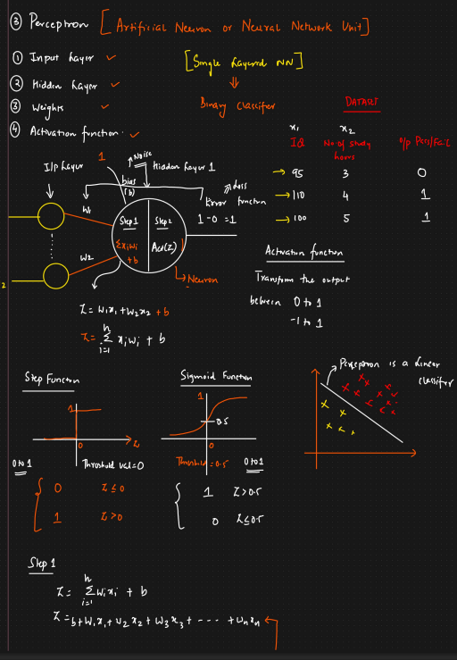

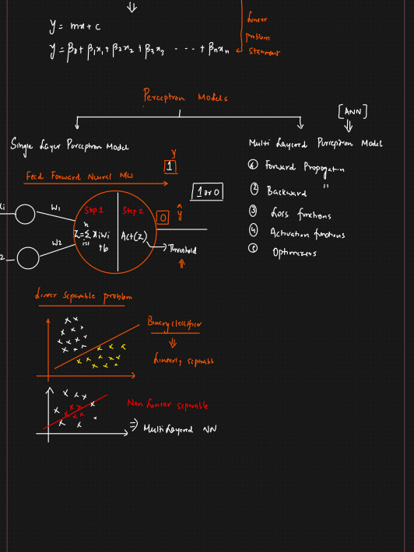

Lecture 2: Single-Layer vs. Multi-Layer Perceptrons (SLP vs. MLP)
1. Single-Layer Perceptron (SLP) Overview
A Single-Layer Perceptron consists of an Input Layer directly connected to a single Output Neuron (the hidden layer contains only one node).
Inputs (X1, X2) ──> [ Feed-Forward Step 1 & 2 ] ──> Output (Y_hat)
│
Compare with True Output (Y)
│
If Error > 0: Update Weights randomly
- Execution Flow (Feed-Forward):
  - Information moves strictly in one direction: Left $→$ Right.
  - Compute weighted sum: $z=\sum{\left(w_{i}x_{i}\right)}+b$
  - Apply activation function: $\overset{ˆ}{y}=f\left(z\right)$
- Weight Update Mechanism in SLP:
  - If predicted output ($\overset{ˆ}{y}$) does not match actual target ($y$), weights are adjusted manually or through random guess/heuristic iterations.
  - Major Drawback: Lacks a systematic, mathematical rule to propagate error backward and calculate exact weight gradients.
2. Advantages & Limitations of SLP
Advantages
- Simple & Fast: Highly efficient for simple mathematical decisions.
- Effective for Linearly Separable Data: Guarantees convergence if a single straight line (or flat hyperplane) can cleanly partition two classes.
Disadvantages
- Inability to Solve Non-Linear Problems: Cannot draw curved, complex, or multiple decision boundaries (e.g., fails on XOR classification tasks).
- Inefficient Weight Training: Feed-forward trial and error lacks an optimization mechanism to adjust weights based on exact error magnitude.
- No Scaling Potential: Cannot learn hierarchical or abstract feature representations.
3. Linearly Separable vs. Non-Linearly Separable Data
Feature | Linearly Separable | Non-Linearly Separable
Separation Line | Single straight line / hyperplane | Curved, complex, or multiple lines
Data Pattern | Distinct, isolated clusters | Overlapping, concentric, or interleaved patterns (e.g., XOR)
Model Required | Single-Layer Perceptron (SLP) | Multi-Layer Perceptron (MLP / ANN)
4. Transition to Multi-Layer Perceptrons (MLP / ANN)
To overcome the limitations of SLPs, Multi-Layer Perceptrons (MLPs)—also referred to as Artificial Neural Networks (ANNs)—introduce multiple hidden layers, non-linear activation functions, and systematic training algorithms.
Core Foundations of MLP Architecture
[ Input Layer ] ──> [ Hidden Layer 1 ] ──> [ Hidden Layer 2 ] ──> [ Output Layer ]
│ │
└─────────────────── Loss Function ──────────────────────────────┘
│
Backward Propagation
│
Optimizers
- Forward Propagation:
  - Data passes sequentially through multiple hidden layers to generate predictions.
- Loss / Cost Functions:
  - Quantifies the exact difference between predictions ($\overset{ˆ}{y}$) and true targets ($y$).
  - Examples: Mean Squared Error (MSE), Binary Cross-Entropy.
- Backpropagation (The Breakthrough Invention):
  - Uses the Chain Rule of Calculus to calculate gradients of the loss function with respect to every weight in every layer, working from Right $→$ Left.
- Optimizers:
  - Mathematical algorithms that use computed gradients to systematically update weights in the direction of steepest loss reduction.
  - Examples: Gradient Descent, Stochastic Gradient Descent (SGD), Adam.
- Advanced Activation Functions:
  - Non-linear activation functions (e.g., ReLU, Leaky ReLU, Tanh, Softmax) allow the network to learn non-linear decision boundaries.
5. Comparative Summary: SLP vs. MLP
Feature | Single-Layer Perceptron (SLP) | Multi-Layer Perceptron (MLP)
Architecture | 1 Input Layer + 1 Output Neuron | Input Layer + $≥1$ Hidden Layers + Output Layer
Decision Boundary | Strictly Linear | Non-Linear & Arbitrarily Complex
Supported Tasks | Simple Binary Classification | Regression, Multi-Class Classification, Complex Pattern Recognition
Key Algorithms | Basic Feed-Forward | Forward Propagation + Backpropagation
Optimization | Random/Heuristic weight tweaks | Gradient-Based Optimizers (Adam, SGD)

Lecture 3: Fundamentals of Multi-Layer Perceptrons (Forward & Backward Propagation)
1. Multi-Layer Perceptron (MLP) Architecture Overview
Unlike a Single-Layer Perceptron, an MLP (also known as an Artificial Neural Network or ANN) contains one or more hidden layers placed between the input layer and output layer.
[ Input Layer ] [ Hidden Layer 1 ] [ Hidden Layer 2 / Output ]
(Features) (Neuron O1) (Neuron O2)
────────── ─────────── ───────────
x₁ (IQ) ────(w₁)────┐
x₂ (Study)───(w₂)────┼──> z₁ = Σwᵢxᵢ + b₁ ──> f(z₁) = O₁ ──(w₄)──┐
x₃ (Play) ───(w₃)────┘ ├──> z₂ = O₁w₄ + b₂ ──> f(z₂) = O₂ (ŷ)
┌──┘
(b₂)
Architectural Parameters
- Input Features ($x_{1},x_{2},x_{3}$): IQ, Study Hours, Play Hours.
- Layer 1 Weights ($w_{1},w_{2},w_{3}$) & Bias ($b_{1}$): Connect inputs to Hidden Layer 1.
- Layer 2 Weight ($w_{4}$) & Bias ($b_{2}$): Connect Hidden Layer 1 output ($O_{1}$) to the Output Neuron ($O_{2}$).
2. Comprehensive Forward Propagation Step-by-Step
Forward propagation processes input features sequentially from left to right through every layer to compute a final output estimate ($\overset{ˆ}{y}$).
Given Initial Parameters (Sample Values):
- Inputs: $x_{1}=95$ (IQ), $x_{2}=4$ (Study), $x_{3}=4$ (Play).
- Hidden Layer 1 Weights: $w_{1}=0.01,w_{2}=0.02,w_{3}=0.03$, Bias $b_{1}=0.001$.
- Hidden Layer 2 Weights: $w_{4}=0.02$, Bias $b_{2}=0.03$.
Step A: Computation in Hidden Layer 1
- Weighted Sum ($z_{1}$):
$$z_{1}=\left(x_{1}w_{1}\right)+\left(x_{2}w_{2}\right)+\left(x_{3}w_{3}\right)+b_{1}$$
$$z_{1}=\left(95×0.01\right)+\left(4×0.02\right)+\left(4×0.03\right)+0.001$$
$$z_{1}=0.95+0.08+0.12+0.001=1.151$$
- Sigmoid Activation ($O_{1}$):
$$f\left(z\right)=σ\left(z\right)=\frac{1}{1+e^{-z}}$$
$$O_{1}=σ\left(1.151\right)=\frac{1}{1+e^{-1.151}}≈0.759$$
Step B: Computation in Output Layer (Hidden Layer 2)
- Weighted Sum ($z_{2}$):
$$z_{2}=\left(O_{1}×w_{4}\right)+b_{2}$$
$$z_{2}=\left(0.759×0.02\right)+0.03=0.01518+0.03=0.04518$$
- Sigmoid Activation ($O_{2}$ / $\overset{ˆ}{y}$):
$$\overset{ˆ}{y}=O_{2}=σ\left(0.04518\right)=\frac{1}{1+e^{-0.04518}}≈0.51129$$
3. Loss Calculation & Optimization Pipeline
Once forward propagation yields a predicted output $\overset{ˆ}{y}=0.51129$, it is compared against the actual ground truth $y=1.0$:
$$\text{Error}=|y-\overset{ˆ}{y}|=|1.0-0.51129|=0.48871$$
Because this error is high, the model must adjust its internal weights ($w_{1},w_{2},w_{3},w_{4}$) and biases ($b_{1},b_{2}$) to reduce prediction error.

Backpropagation & Geoffrey Hinton's Contribution
- Geoffrey Hinton (often referred to as a "Godfather of Deep Learning") popularized the Backpropagation Algorithm for deep neural networks.
- Mechanism: Backpropagation applies the Chain Rule of Calculus to compute the gradient (partial derivative) of the loss function with respect to each weight, moving in reverse from the output layer back to the input layer.
4. Key Concepts: Loss vs. Cost & Activation Functions
Loss Function vs. Cost Function
Parameter | Loss Function | Cost Function
Scope | Evaluates error for a single training example. | Evaluates average error across the entire dataset (or batch).
Formula | $$L={\left(y-\overset{ˆ}{y}\right)}^{2}$$ | $$J=\frac{1}{N}\sum_{i=1}^{N}{L_{i}}$$
Usage | Computes instance-level prediction variance. | Drives weight updates during training epochs/batches.
Activation Functions
- Sigmoid Function: Maps real numbers to the open interval $\left(0,1\right)$. It is often used in output layers for binary classification.
- Role in Processing: Acts as a gate determining neuron activation level. High activation signals importance (e.g., triggering a motor response to pain), whereas zero deactivates irrelevant neurons.
5. Core Architectural Takeaways
- Forward Propagation calculates linear combinations ($z=w^{T}x+b$) followed by non-linear activations ($O=σ\left(z\right)$) across all neurons from left to right.
- Backpropagation flows right to left, using calculus chain rules to trace how changes in each weight impact the overall error.
- Optimizers (e.g., SGD, Adam) use these computed gradients to update parameters ($w_{new}=w_{old}-η⋅∇L$) and minimize model error over training iterations.
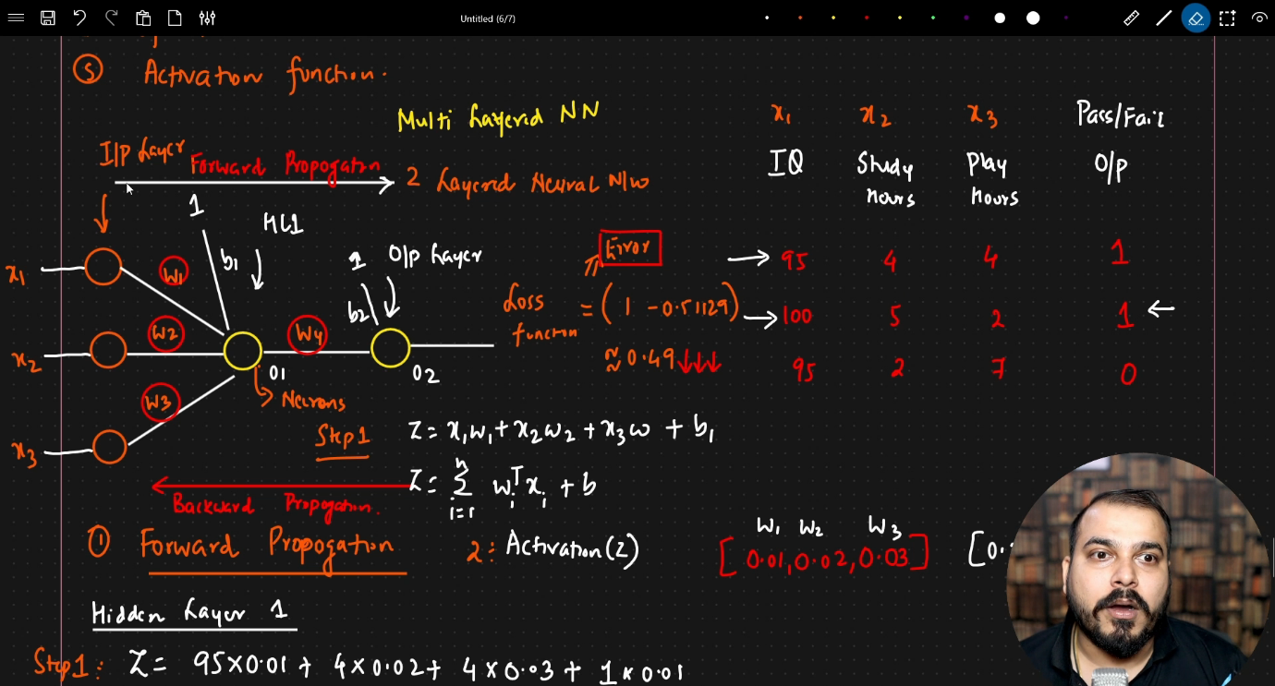

Deep Learning Notes: Backpropagation & Weight Update Mechanics
1. Network Architecture Overview & Output Layer Setup
The example neural network features a 2-layer architecture consisting of one hidden layer and one output layer.
[ Input Layer ] [ Hidden Layer (HL1) ] [ Output Layer ]
(3 Inputs) (2 Neurons) (1 Neuron)
────────── ─────────── ──────────
x₁ (IQ) ─────(w₁,w₂)──────┐
x₂ (Study)───(w₃,w₄)──────┼───> [ Neuron 1 ] ───(w₇)───┐
x₃ (Play) ───(w₅,w₆)──────┘ [ Neuron 2 ] ───(w₈)───┴───> Output Layer (ŷ)
│
Binary Output (0/1)
- Inputs ($x_{1},x_{2},x_{3}$): Independent features (e.g., IQ, Study Hours, Play Hours).
- Hidden Layer: Composed of 2 neurons with bias terms ($b_{1},b_{2}$) added. Weights $w_{1}$ through $w_{6}$ connect the inputs to this hidden layer.
- Output Layer: Uses 1 neuron with incoming weights $w_{7}$ and $w_{8}$.
Why a Single Output Neuron?
- Binary Classification: A single output neuron suffices to generate binary decisions ($0$ or $1$, e.g., Pass/Fail).
- Multi-Class Classification: Multiple output neurons are added to handle categorical targets with more than two potential outputs.
2. Common Loss Functions Summary
Loss functions measure the variance between the model's prediction ($\overset{ˆ}{y}$) and the true target ($y$).
Task Type | Loss Function | Application Context
Regression | Mean Squared Error (MSE) | Continuous values; penalizes larger errors exponentially
 | Mean Absolute Error (MAE) | Linear penalty for continuous output prediction variance
 | Huber Loss | Combines MSE and MAE to handle outliers cleanly
Classification | Binary Cross-Entropy | Single output neuron predicting binary labels ($0$ or $1$)
 | Categorical Cross-Entropy | Multi-class setup predicting probabilities across $K$ classes
3. General Weight Update Equation
During backpropagation, parameter adjustments originate from the loss at the output layer and propagate backward through the network parameters.
Layer-Specific Output Equations:
$$w_{7,\text{new}}=w_{7,\text{old}}-η⋅\frac{∂L}{∂w_{7,\text{old}}}$$
$$w_{8,\text{new}}=w_{8,\text{old}}-η⋅\frac{∂L}{∂w_{8,\text{old}}}$$
Generic Weight Update Formula:
$$w_{\text{new}}=w_{\text{old}}-η⋅\frac{∂L}{∂w_{\text{old}}}$$
Where:
- $w_{\text{old}}$: Initial weight prior to gradient iteration.
- $w_{\text{new}}$: Updated parameter after backpropagation step.
- $η$ (Learning Rate): Hyperparameter governing step size along the gradient curve.
- $\frac{∂L}{∂w_{\text{old}}}$: Gradient/Slope representing the derivative of loss $L$ with respect to weight $w_{\text{old}}$.
4. Mechanics of Gradient Descent Optimization
The gradient descent plot graphs total Loss ($L$) relative to parameter Weight ($w$):
Loss (L)
│
│ \ /
│ \ (-ve Slope) / (+ve Slope)
│ \ /
│ \ /
│ \ /
│ └─── ─────┘
│ Global Minima (Slope = 0)
└───────────────────────────────────── Weight (w)
Case 1: Negative Slope ($\frac{∂L}{∂w}<0$)
- Position: Weight lies on the left side of global minima.
- Slope Mechanics: The right side of the tangent line points downwards.
- Formula Calculation:
$$w_{\text{new}}=w_{\text{old}}-η⋅\left(-\text{Slope}\right)=w_{\text{old}}+η⋅|\text{Slope}|$$
- Effect: $w_{\text{new}}>w_{\text{old}}$ (Weight increases, shifting right toward global minima).
Case 2: Positive Slope ($\frac{∂L}{∂w}>0$)
- Position: Weight lies on the right side of global minima.
- Slope Mechanics: The right side of the tangent line points upwards.
- Formula Calculation:
$$w_{\text{new}}=w_{\text{old}}-η⋅\left(+\text{Slope}\right)=w_{\text{old}}-η⋅|\text{Slope}|$$
- Effect: $w_{\text{new}}<w_{\text{old}}$ (Weight decreases, shifting left toward global minima).
Case 3: Global Minima Reached ($\frac{∂L}{∂w}=0$)
- Slope Value: Gradient equals zero at the local/global minimum point.
- Result: $w_{\text{new}}=w_{\text{old}}$ (Weight updates cease as optimal convergence is established).
5. Learning Rate ($η$) Dynamics
Setting | Step Behavior | Result
Large Value | Overly large jump across loss surfaces | Oscillates wildly and may never converge
Small Value ($≈0.001$) | Measured, iterative steps toward minima | Smooth convergence to global minimum
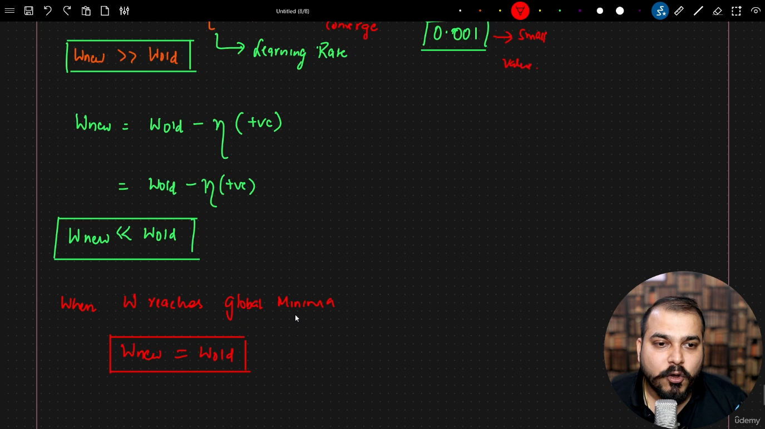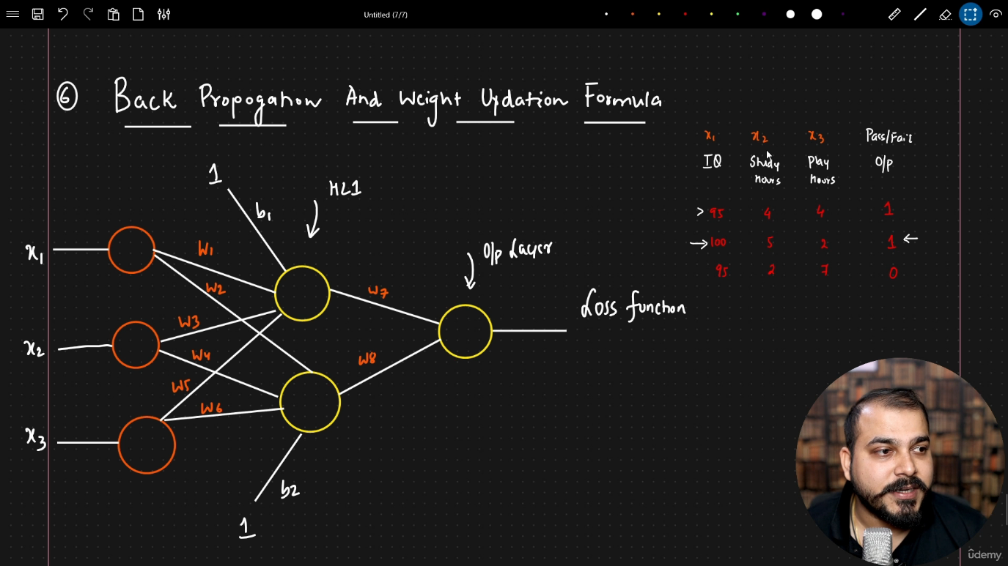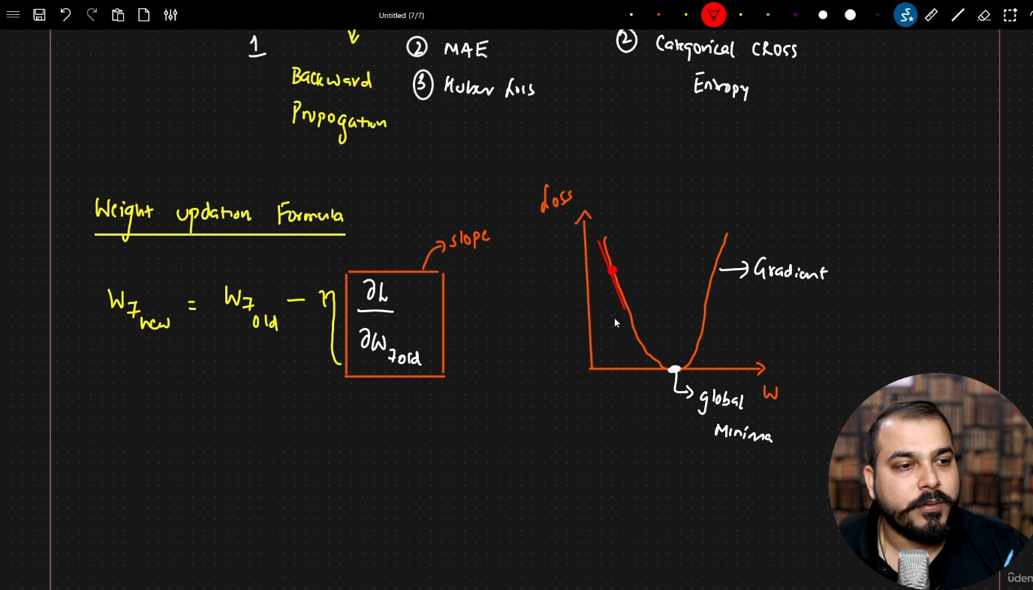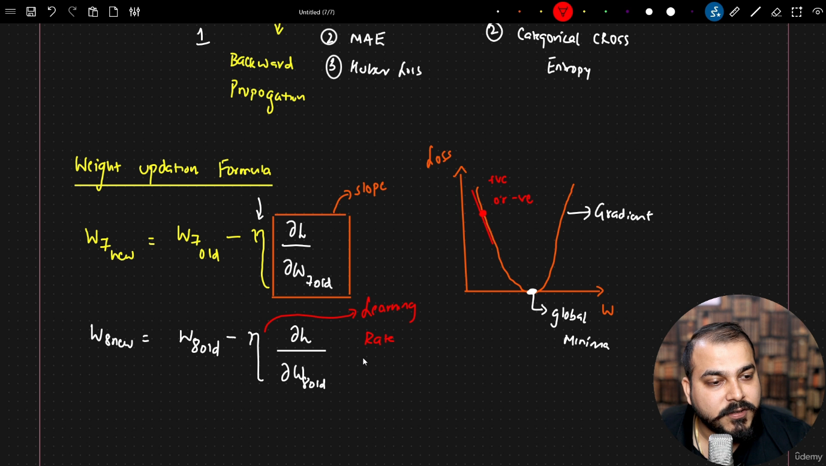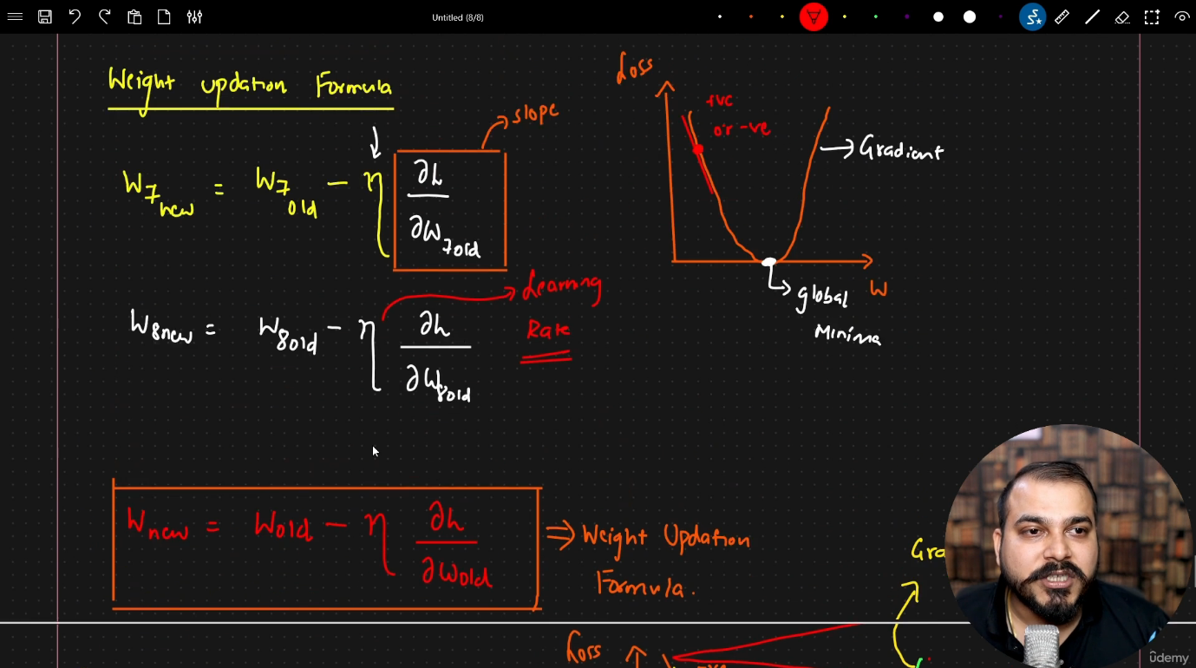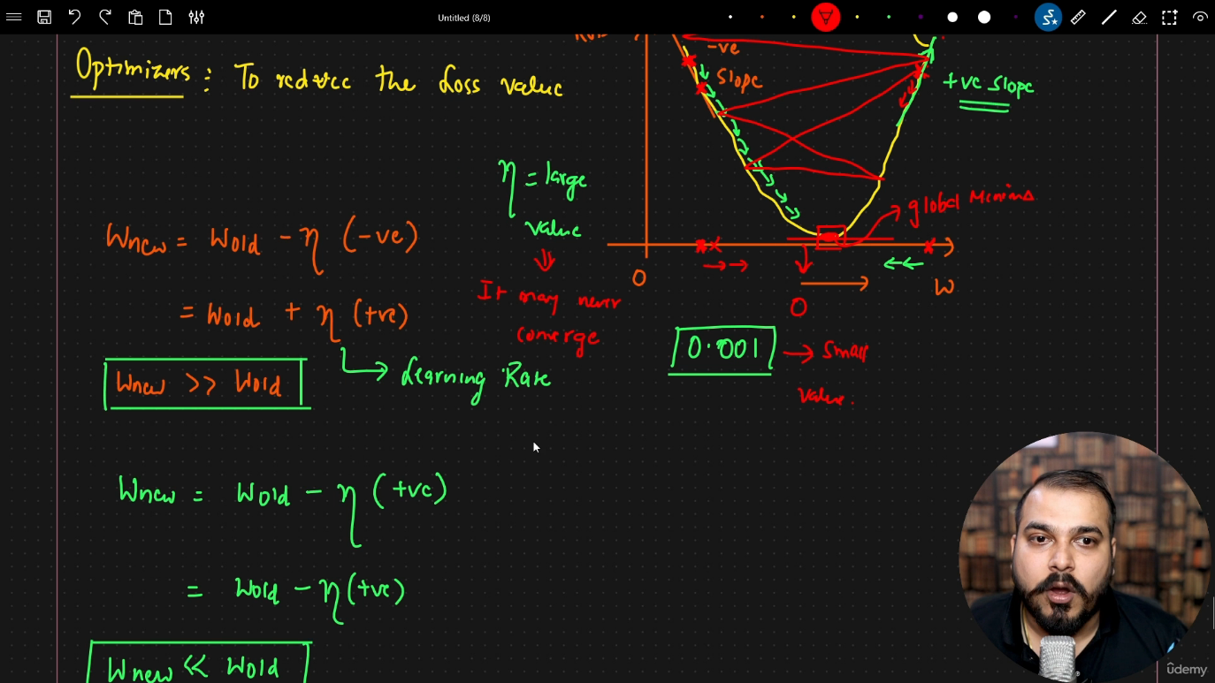

Lecture 5: Chain Rule of Derivatives in Backpropagation
1. Core Weight Update Formula
During backpropagation, every parameter (weight/bias) in a neural network is updated according to the standard gradient descent update rule:
$$w_{\text{new}}=w_{\text{old}}-η⋅\frac{∂L}{∂w_{\text{old}}}$$
Where:
- $w_{\text{old}}$: Current weight value.
- $w_{\text{new}}$: Updated weight parameter.
- $η$: Learning rate (hyperparameter scaling step size).
- $\frac{∂L}{∂w_{\text{old}}}$: Partial derivative of the loss function $L$ with respect to $w_{\text{old}}$ (the error gradient/slope).
2. Chain Rule: Single Path Backpropagation
When computing gradients for weights in deeper layers, partial derivatives cannot be computed directly and must be expanded into intermediate partial derivatives using the Chain Rule of Calculus.
Architecture Setup (Single Path)
- Input Layer: $x_{1},x_{2},x_{3}$.
- Hidden Layer 1 (HL1): Neuron generating output $O_{1}$ with weights $w_{1},w_{2},w_{3}$.
- Output Layer: Neuron generating output $O_{2}$ connected via weight $w_{4}$.
[ Input Layer ] [ Hidden Layer (HL1) ] [ Output Layer ]
(x₁, x₂, x₃) (O₁) (O₂)
────────── ──── ────
x₁ ──(w₁)───┐
x₂ ──(w₂)───┼────────────> [ O₁ ] ──────(w₄)───────────> [ O₂ ] ──────> Loss (L)
x₃ ──(w₃)───┘
Derivation for Output Layer Weight ($w_{4}$)
Loss $L$ depends directly on output $O_{2}$, which in turn depends on $w_{4}$:
$$\frac{∂L}{∂w_{4,\text{old}}}=\frac{∂L}{∂O_{2}}⋅\frac{∂O_{2}}{∂w_{4,\text{old}}}$$
$$w_{4,\text{new}}=w_{4,\text{old}}-η⋅\left[\frac{∂L}{∂O_{2}}⋅\frac{∂O_{2}}{∂w_{4,\text{old}}}\right]$$
Derivation for Early Hidden Layer Weight ($w_{1}$)
To update an earlier weight $w_{1}$, the error must propagate back through $O_{2}$ and $O_{1}$:
- Loss $L$ depends on output $O_{2}$.
- Output $O_{2}$ depends on intermediate activation $O_{1}$.
- Activation $O_{1}$ depends directly on weight $w_{1}$.
$$\frac{∂L}{∂w_{1,\text{old}}}=\frac{∂L}{∂O_{2}}⋅\frac{∂O_{2}}{∂O_{1}}⋅\frac{∂O_{1}}{∂w_{1,\text{old}}}$$
$$w_{1,\text{new}}=w_{1,\text{old}}-η⋅\left[\frac{∂L}{∂O_{2}}⋅\frac{∂O_{2}}{∂O_{1}}⋅\frac{∂O_{1}}{∂w_{1,\text{old}}}\right]$$
3. Chain Rule: Multi-Path Backpropagation
When an early neuron feeds into multiple hidden neurons in subsequent layers, the gradient branches. According to multivariable calculus, the total gradient is the sum of partial derivatives along all parallel paths connecting that weight to the loss function.
Multi-Path Architecture Setup
┌──> [ HL2: Neuron O₂₁ ] ──(w₄)──┐
[ Input ] │ │ [ Output Layer ]
x₁ ──(w₁)──> [ HL1: Neuron O₁₁ ] ├───> [ O₃₁ ] ───> Loss (L)
│ │
└──> [ HL2: Neuron O₂₂ ] ──(w₅)──┘
- Hidden Layer 1 (HL1): Neuron with activation output $O_{11}$ receiving input via weight $w_{1}$.
- Hidden Layer 2 (HL2): Two parallel neurons with activation outputs $O_{21}$ (connected via $w_{2}$) and $O_{22}$ (connected via $w_{3}$).
- Output Layer: Single output neuron $O_{31}$ receiving signals from $O_{21}$ (via $w_{4}$) and $O_{22}$ (via $w_{5}$).
Total Gradient Equation for $w_{1}$
Because weight $w_{1}$ influences the final loss through two distinct pathways ($O_{11}→O_{21}→O_{31}$ and $O_{11}→O_{22}→O_{31}$), both paths are summed together:
$$\frac{∂L}{∂w_{1,\text{old}}}=\underset{\text{Upper Path (via }O_{21}\text{)}}{\underbrace{\left[\frac{∂L}{∂O_{31}}⋅\frac{∂O_{31}}{∂O_{21}}⋅\frac{∂O_{21}}{∂O_{11}}⋅\frac{∂O_{11}}{∂w_{1,\text{old}}}\right]}}+\underset{\text{Lower Path (via }O_{22}\text{)}}{\underbrace{\left[\frac{∂L}{∂O_{31}}⋅\frac{∂O_{31}}{∂O_{22}}⋅\frac{∂O_{22}}{∂O_{12}}⋅\frac{∂O_{12}}{∂w_{1,\text{old}}}\right]}}$$
4. Key Takeaways
- Chain Rule Utility: Enables explicit gradient calculation for any weight deep inside a neural network, regardless of depth.
- Gradient Splitting / Summation: When backpropagating error through nodes that branch into multiple forward connections, the total gradient with respect to an earlier weight is the sum of gradients flowing back through each individual path.
- Efficiency in Practice: Frameworks like PyTorch and TensorFlow construct a Computation Graph (Autograd) during forward propagation to efficiently evaluate these exact chain rule equations in reverse during backpropagation.
